# Einstein’s Riddle Documentation

*In this Lab we are going to create a C# program that generates a random* [*Einstein’s riddle*](https://udel.edu/~os/riddle.html) *each time the program is started. It will also have a functionality to print the solution if the user has trouble solving it. At the end it is going to look like this:*

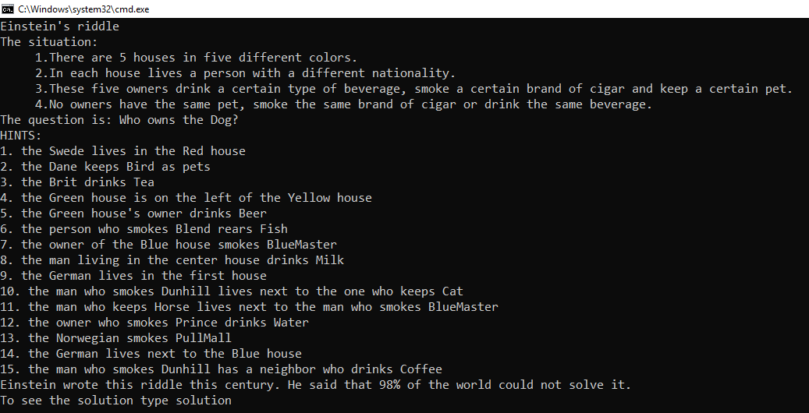

**Creating the Project**

Create new .NET Core project in Visual Studio

**Creating the Sets**

First, we need **5 arrays** to store the information about the **houses, nationalities, drinks, cigarettes** and **pets**. We also need to store the **hints**, because we want to write them on the console. For them to be accessible in all of the code, we are going to create them as **static variables on top of the Main method**.

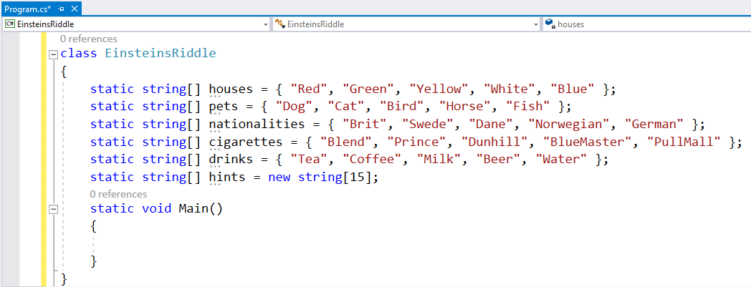

* It does not matter, how the info is ordered. We are going to **shuffle** it anyway.
* The hints array should have **15 elements**, because we are going to create **15 hints**

**Random and Shuffling**

Now to shuffle the info, we need a random generator, so we create it

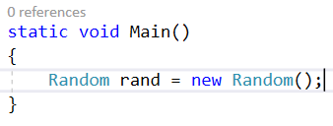

Now we need a method that shuffles each array of info, so we have new riddle every time we start the program

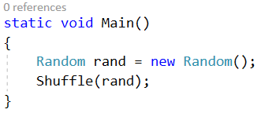

* We create the method and pass it the random generator we have created. We are going to use the Fisher-Yates Shuffle Algorithm to shuffle the data:

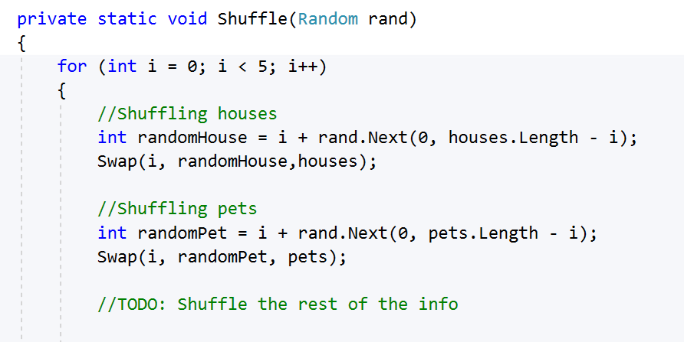

* We use a **for-loop**. In this case the iterations are 5, because the length of each of the arrays is 5.
* We take **a random index from every array** and create a **Swap method** that is going to swap the data at the given **indices** from the given **array of data**.
* We repeat that for each of the arrays we have.

**The Swap Method**

The method is going to receive **2 indices and an array and it is going to swap them**:

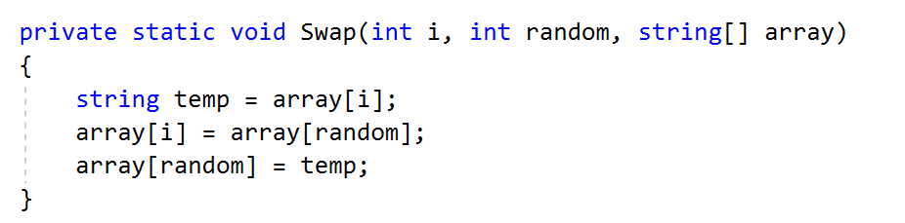

* We **store the value of the first index** from the given array of data
* We **set the first value to the second value**
* We **set the second value to the stored value**

## Generating the Hints

The next step after we shuffled all the data is, to **generate the hints**. We follow the **original hints** of the riddle. If you open the [solution](https://udel.edu/~os/riddle-solution.html) (**scroll to the bottom** to see the solution table) and **check for the first hint**, you will see that it reveals the user the **nationality of the person living in the 3rd house** and the **color of that house**. (in our case we **start counting from 0** because we use **arrays**, so for us it is the **second index**) We do that for all the **15 hints**.

First let us call a method **GenerateHints in our main method:**

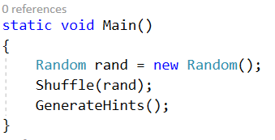

Now let us **create it,** following the original riddle:

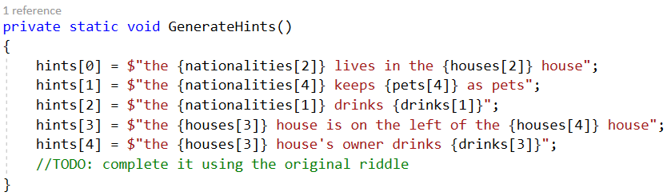

* Check what kind of info we give the user using the hints of the riddle and the solution

**Printing the Info for the User**

We are almost done. Now we have to provide the user with the intro and the hints of the riddle. Use the link to write on the console the intro:

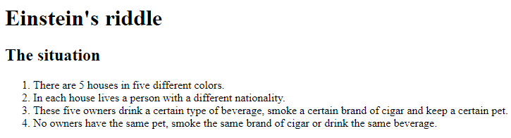

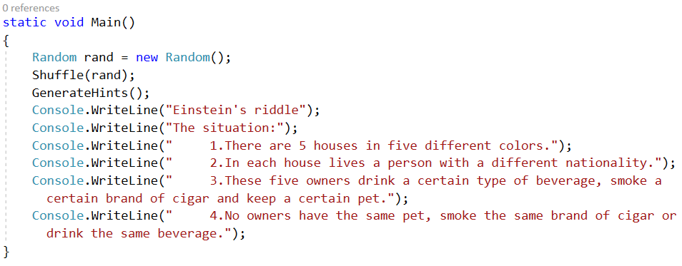

For the question we see the riddle and the solution (the **fish is the 3rd index of our pets array**)



Now we have to loop through the hints and print them:

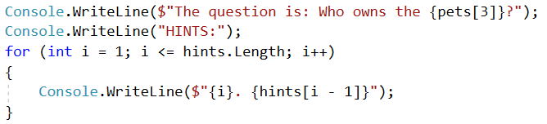

Now we have to check if the user wants to see the solution. We write the following code:

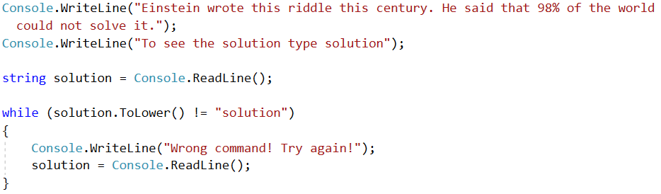

* We wait for the user to type something (it is possible for him to write everything).
* Until we receive a string that says "solution", we say the user that the command is invalid   
  and read the string again.
* If the string is correct we proceed.

**Printing the Solution**

If the user asks for the solution we want to print it. So, we create a method called PrintSolution and call it in the Main method after the while loop:

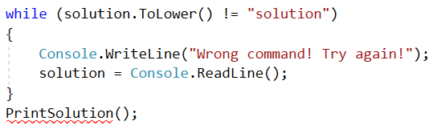

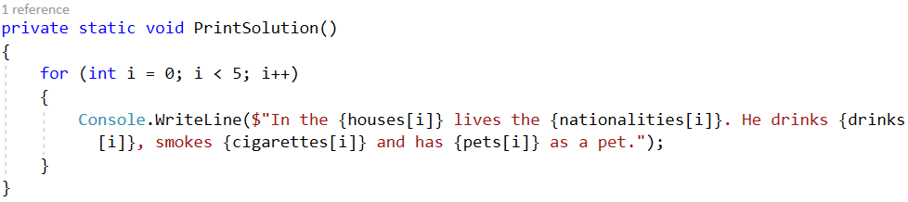

* The method will just loop **5 times** to print the info about each person with his **house, drink, nationality, pet and cigarettes.**

***Ready! Now you can try running the program and solving the riddle!*** 😊